**University of Petroleum and Energy Studies**

School of Computer Science

Department of Cybernetics



**Graphics & Animation Tools**

**LAB FILE**

**(Session: 2020-2021)**

**Course:** B. Tech with Specialization in Open Source and Open Standards

**Batch:** 2017-2021

**Semester:** VIIth

**Submitted By: -**

Ananya Raghav

Roll No: R100217008

SAP ID: 500062570

**Submitted To: -**

Dr. Durgansh Sharma Assistant Professor

Department of Cybernetics

**Experiment-1**

**Aim:** Installation of GIMP and BLENDER.

**Steps followed:**

**a)- Installation of GIMP**

1. For installing GIMP from the official website, visit <https://www.gimp.org/> for the latest version which is 2.10.20.

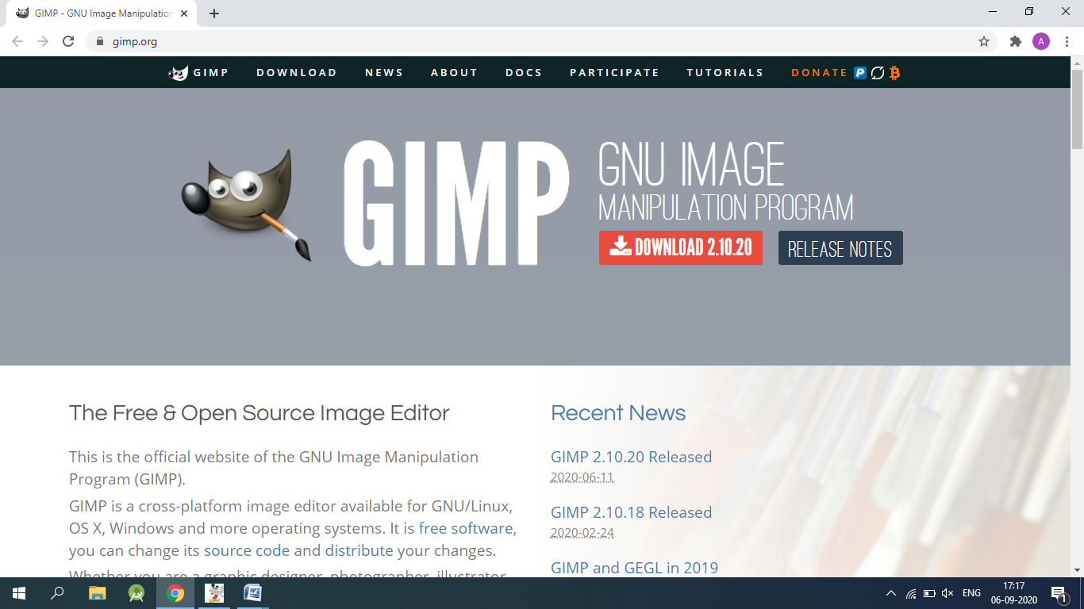

2.Click on DOWNLOAD and complete the setup process.

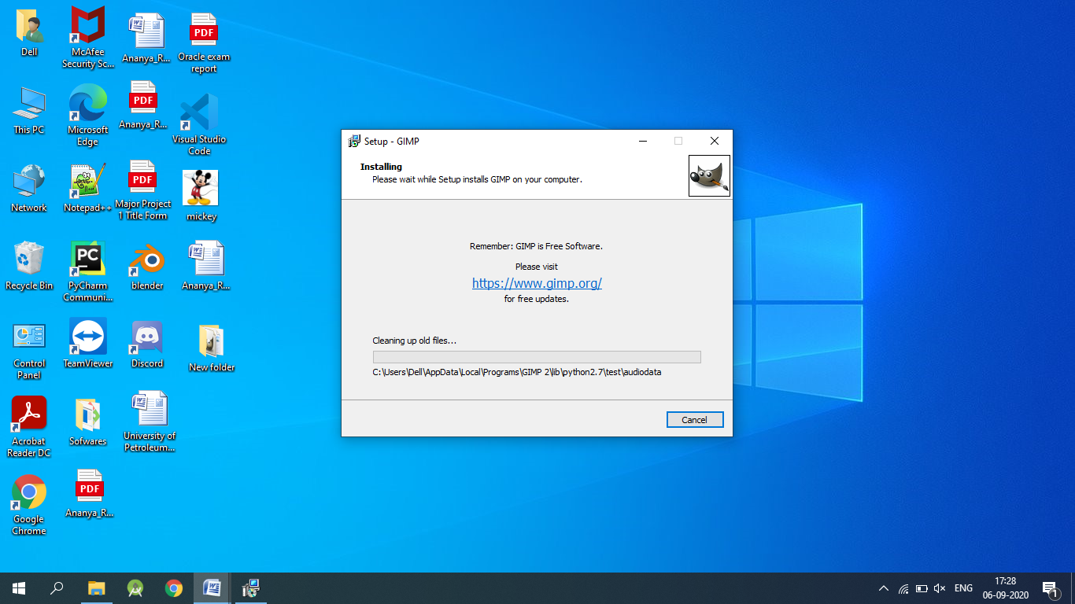

3. After the setup is finished, open GIMP.

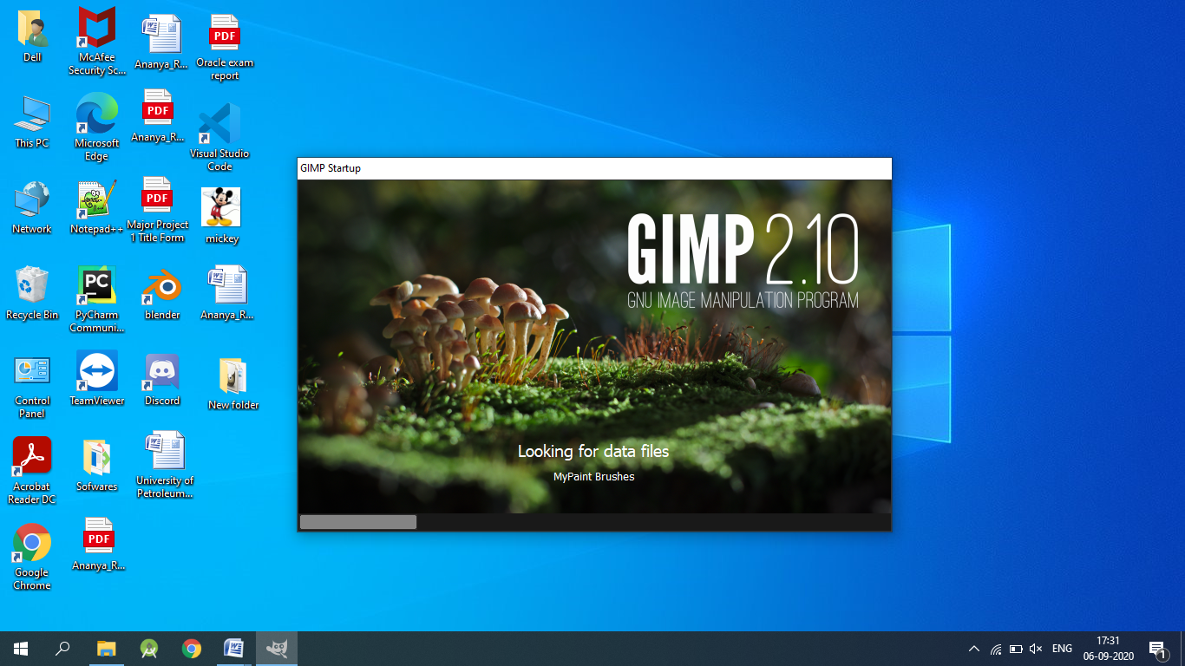

4. You are good to go.

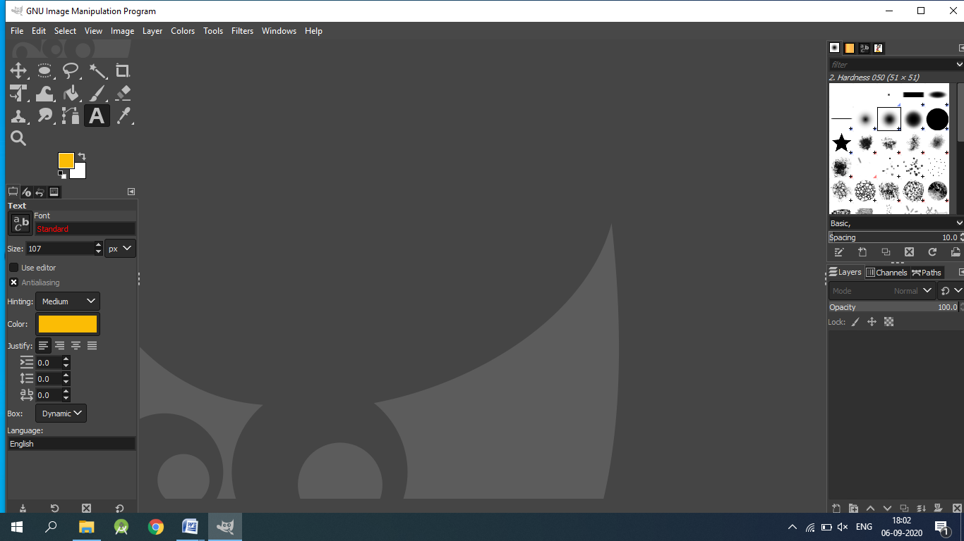

**b) Installation of Blender-**

1. For installing Blender from the official website, go to <https://www.blender.org/download/>

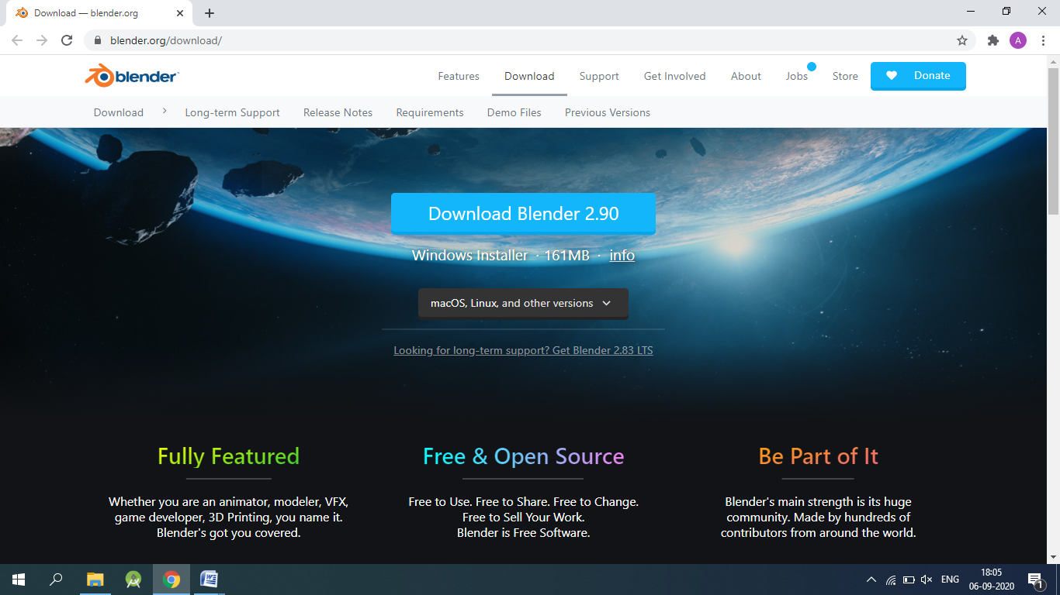

2. Select windows installer(or macOS, Linux) and click on download to install the lastest version of Blender i.e. 2.90.

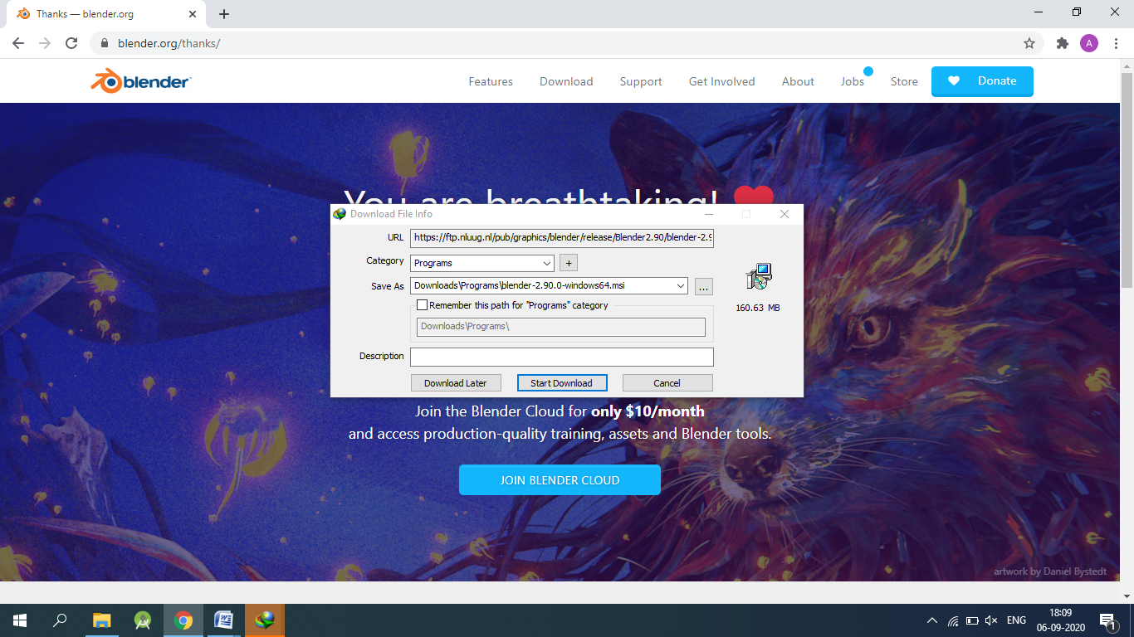

3. Open the Blender setup wizard and click next.

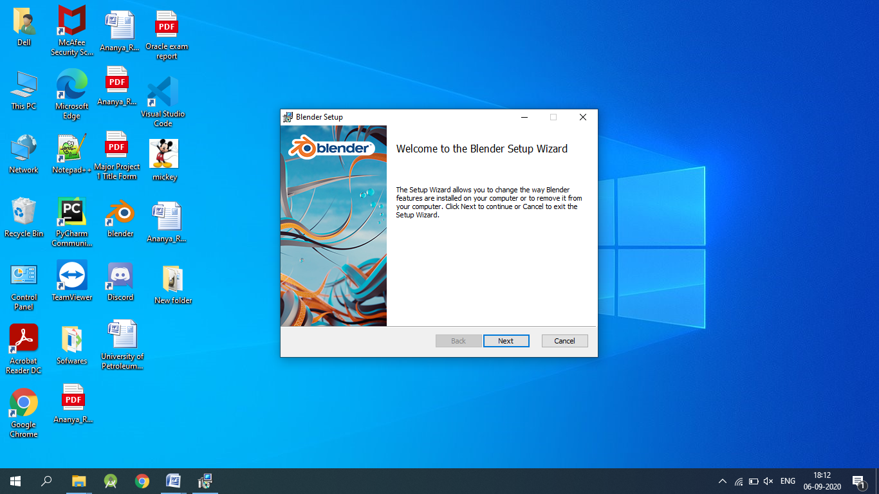

4. Click the checkbox and press next.

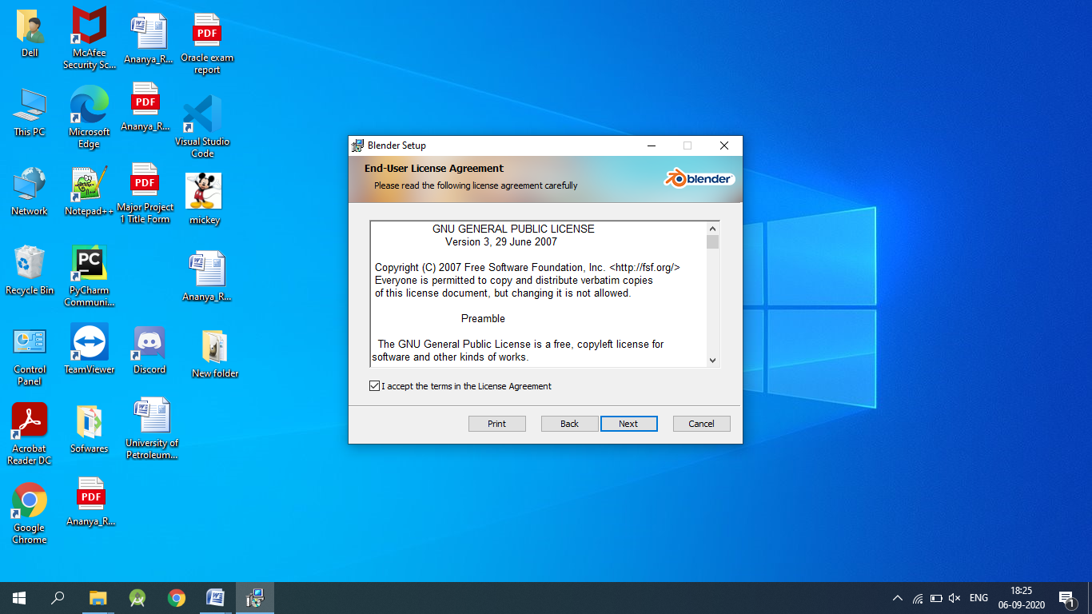

5. Select the way you want the features to be installed and click next.

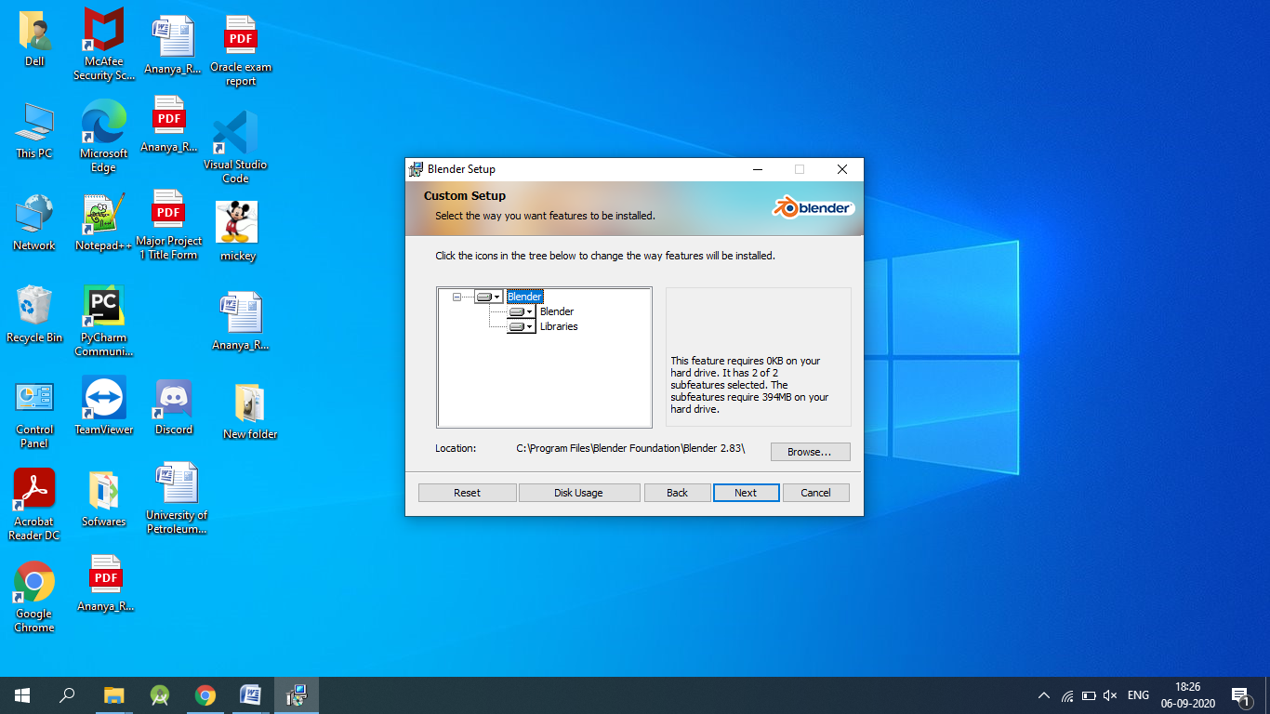

6. Click Install.

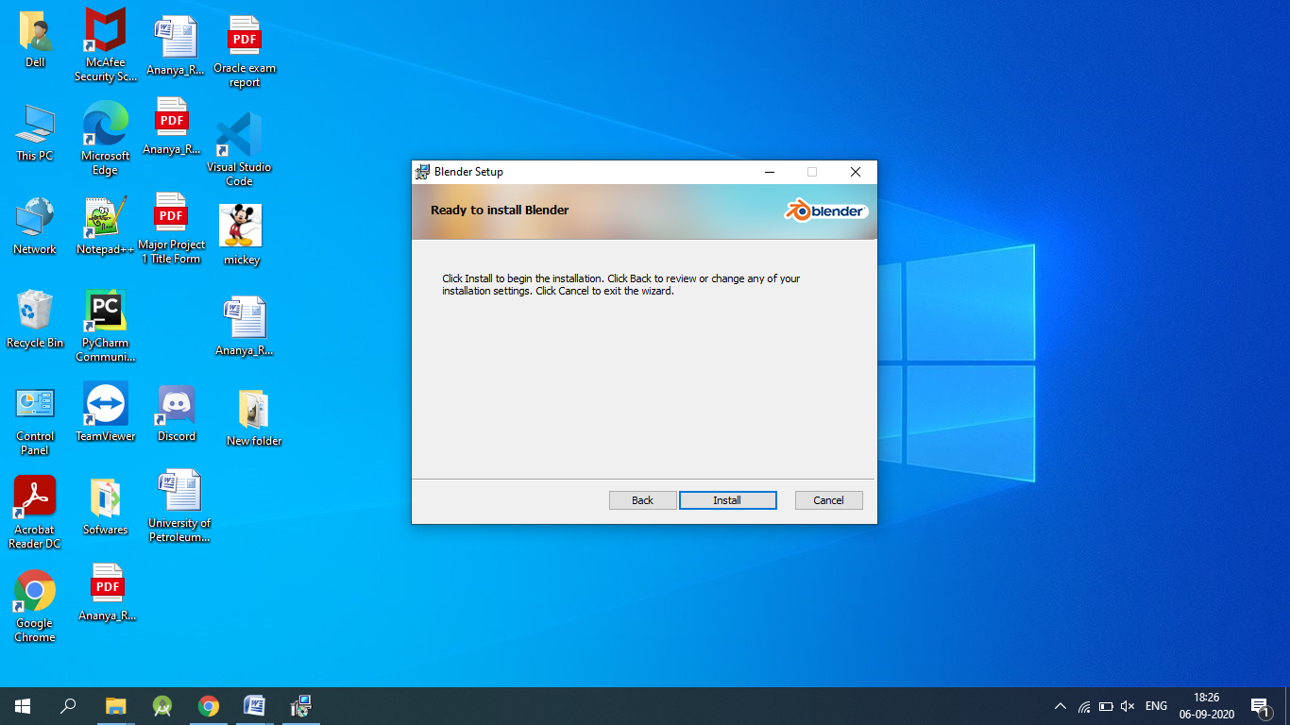

7. Once Blender is installed click on finish to exit the setup wizard.

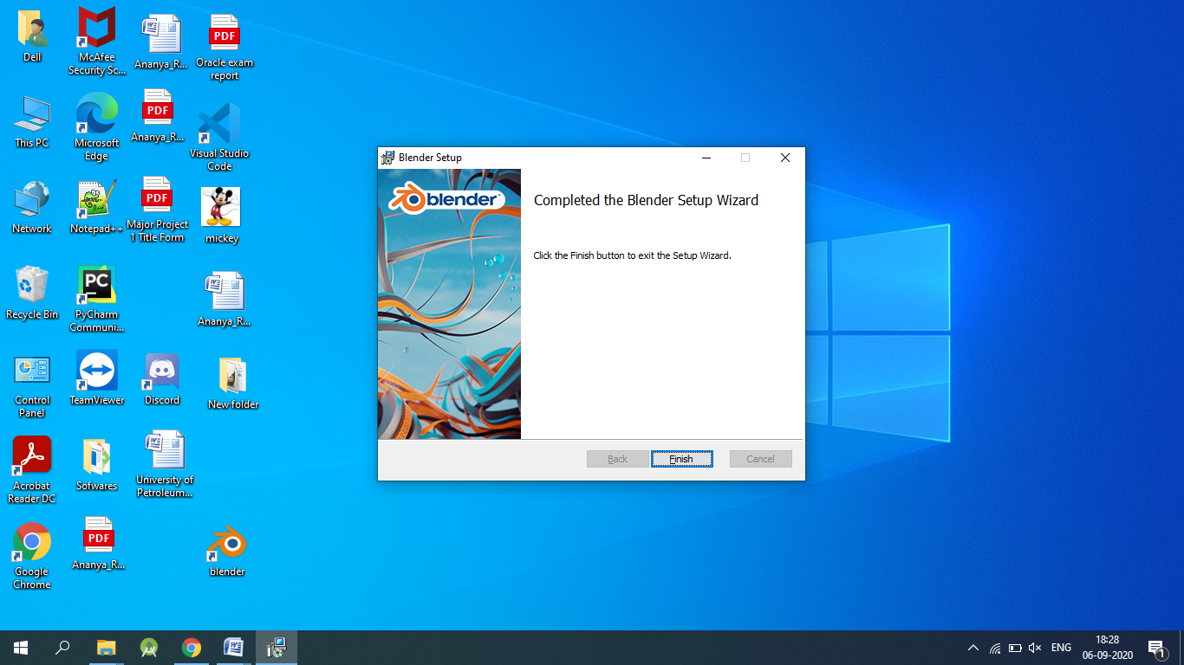

8. Now open Blender and you are good to go.

